Implementation of a Light Weight Blockchain

A Thesis submitted in partial fulfillment of the requirements for degree of
Master of Computer Application
Department of Computer Science and Engineering
Jadavpur University, Kolkata

By
Kallol Chowdhury
Examination Roll No: MCA- MCA196022
Registration No: 137333 of 2016-17

Under the guidance of
Mridul Sankar Barik
Assistant Professor
Department of Computer Science & Engineering
Jadavpur University
Kolkata – 700 032

May, 2019

Department of Computer Science and Engineering,
Faculty of Engineering and Technology,
Jadavpur University, Kolkata 700032

Certificate of Approval

This is to certify that the thesis entitled “Implementation of a Light Weight Blockchain” is a bona-fide record of work carried out by Kallol Chowdhury in partial fulfillment of the requirements for the award of the degree of Master of Computer Application, in the Department of Computer Science and Engineering, Jadavpur University during the period December 2018 to May 2019. It is understood that by this approval, the undersigned do not necessarily endorse or approve any statement made, opinion expressed or conclusion drawn therein, but approve the thesis only for the purpose for which it is submitted.

Examiners:

__________________________ _________________________
(Signature of the Examiner) (Signature of the Supervisor)

To whom it may concern

This is to certify that the work in this thesis entitled “Implementation of a Light Weight Blockchain” has been satisfactorily completed by Kallol Chowdhury. It is a bona-fide piece of work carried out under my supervision and guidance for partial fulfillment of the requirements for the awarding of the Master of Computer Application degree of the Department of Computer Science & Engineering, Faculty of Engineering & Technology, Jadavpur University, during the academic year 2018-19.

___________________________________
Mridul Sankar Barik
Department of
Computer Science & Engineering
Jadavpur University

Countersigned:

__________________________________ |  | ________________________________
Prof. Mahantapas Kundu |  | Prof. Chiranjib Bhattacharjee
Head of the Department |  | Dean
Computer Science & Engineering |  | Faculty of Engineering & Technology
Jadavpur University |  | Jadavpur University

Declaration of Originality and Compliance of Academic Ethics

I hereby declare that this thesis contains literature survey and original research work by the undersigned candidate, as part of my Master of Computer Application studies.

All information in this document has been obtained and presented in accordance with academic rules and ethical conduct.

I also declare that, as required by these rules and conduct, I have fully cited and referenced all material and results that are not original to this work.

Name: Kallol Chowdhury
Exam Roll Number: MCA- MCA196022
Thesis Title: Implementation of a Light Weight Blockchain

Signature with date:

Acknowledgement

With my sincere respect and gratitude, I would like to thank my thesis guide Sri Mridul Sankar Barik for his continuous support for this thesis work, for his patience, motivation and enthusiasm. His guidance helped me a lot throughout the duration of the work. His valuable suggestions inspired me a lot. I feel deeply honored that I got the opportunity to work under his guidance.

I would also wish to thank Prof. Mahantapas Kundu, Head of the Department of Computer Science & Engineering, Jadavpur University for providing me all the facilities and for his support to the activities of this project.

Last, but not the least, I would like to thank all my family members for their co-operation and support. Their wealth of experience has been a source of strength for me throughout the duration of my work.

_______________________________
Kallol Chowdhury
Exam Roll No: MCA- MCA196022
Registration No: 137333 of 2016-19
Master of Computer Application
Contents

1. Introduction 9
1.1 Motivation 10
1.2 Thesis Layout 10
2. Basics of Blockchain Technology 12
2.1 Transactions 13
2.2 Differences between Blockchains and Databases 13
2.3 Immutability of Data 14
2.4 Hashing and Merkle Tree 15
2.4.1 Hashing 15
2.5 Types of Blockchain 17
2.5.1 Centralized vs. Distributed 17
2.5.2 Permissioned vs. Permissionless 18
2.6 Mining 18
2.7 Proof of Work Consensus Model 18
2.8 Smart Contracts 19
3. Applications of Blockchain 20
3.1 Crypto Currencies 20
3.1.1 Bitcoin 20
3.1.2 Ethereum 20
3.2 Blockchain and Customer Loyalty Programs 21
3.3 Agriculture 21
3.4 Blockchain and SDN 23
4. Blockchain Platforms 24
4.1 Hydrachain 24
4.2 Openchain 25
4.3 IBM Bluemix Blockchain 25
4.4 Multichain 25
4.5 Hyperledger 25
4.5.1 Components of Hyperledger Frameworks 27
4.5.2 Hyperledger Iroha 27
4.5.3 Hyperledger Sawtooth 27
4.6 Azure BaaS (Blockchain as a Service) 27
4.7 Other Distributed Ledger Technologies 29
5. Implementation of a BlockChain 30
5.1 Java Crypto API 30
6. Experimental Work 36
7. Future Work and Conclusion 37
8. Bibliography 38

List of Figures

Figure 1-1 Working procedure of Blockchain 9
Figure 2-1 BlockChain 13
Figure 2-2 Centralized Database vs Blockchain 14
Figure 2-3 Blockchain Immutability 15
Figure 2-4 Minor input difference leads to major output diffrences 16
Figure 2-5 Merkle tree as a Binary tree connected by Hash pointer 17
Figure 2-6 Smart Contract 19
Figure 4-1 Hydrachain 24
Figure 4-2 Hyperledger Modular Umbrella Approach 26
Figure 4-3 Azure Blockchain-as-a-Service Stack 28

Abstract

Introduction
Blockchain is the backbone technology of digital crypto currency. It is a distributed database of records of all transactions or digital event that have been shared among participating parties or entities. Transactions are verified by majority of participating parties and its contain each record of all transaction.

One famous use of blockchain is Bitcoin. It is a digital crypto currency and used to exchange digital assets online. Bitcoin use cryptographic proof instead of trusted third party (Bank) to transact. Each transaction is protected through digital signature.

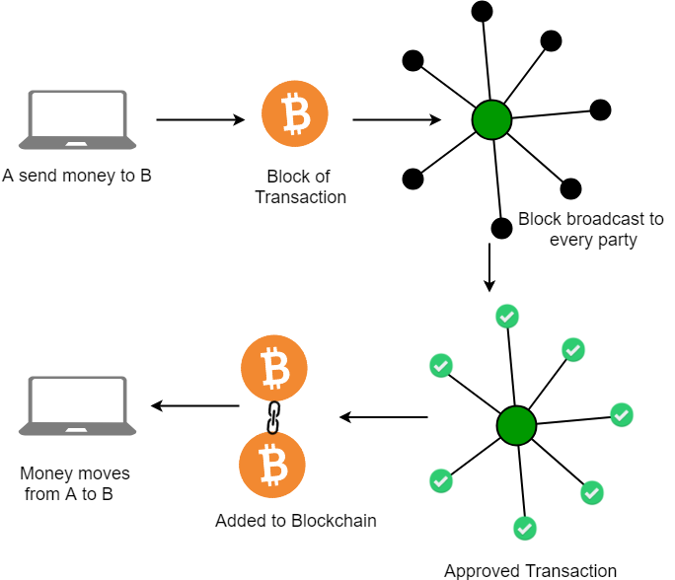

Figure 1-1 Working procedure of Blockchain
One another application of Block chain is Ethereum. Like Bitcoin Ethereum is a distributed public blockchain network. The Ethereum blockchain focuses on running the programming code of any decentralized application. In the Ethereum blockchain, instead of mining for bitcoin, miners work to earn Ether, a type of crypto token that fuels the network. Ether is also used by application developers to pay for transaction fees and services on the Ethereum network.
Blockchain applications were designed to do a very limited set of operations. Bitcoin and other cryptocurrencies for example, were developed exclusively to operate as peer-to-peer digital currencies. Developers faced some problem. Either expand the set of functions offered by Bitcoin and other types of applications, which is very complex and time complexity is high. For this problem Vitalik Buterin creator of Ethereum developed a new platform Ethereum Virtual Machine or shortly called EVM. It is a Turing complete software that runs on the Ethereum network. It enables anyone to run any program, regardless of the programming language given enough time and memory. The EVM makes the process of creating blockchain applications much easier and efficient. Ethereum enables the development of thousands of different applications all on one platform.

Motivation
New investors are the power behind the rise of crypto currency market. Most of these new investors are doing it just to get in on the latest trend, and most do not really understand the Motivation behind crypto currencies. They just want to earn some easy money. They leave the market because the market value to crash. Because such investors don’t fully understand the new economy and the opportunities.

Cryptocurrency lies in its transparency and scalability which create new markets and provide more efficient resource allocation. lets an Indian with a good mastery of the English language can earn a living in customer support or as a freelancer providing translation services paid in a cryptocurrency to his private cryptocurrency wallet. Without having to go through bank. Crypto token is a coin which can be used to pay for a service or which sometimes can function as money.

Thesis Layout
A short type of description of the thesis is described in this section as follows :
1 . Inrtroduction : In this chapter I described the working procedure of Blockchain technology, usual examples of Blockchain such as Bitcoin, Ethereum and the motivation behind the use of Blockchain technology.

2 . Basics of Blockchain Technology : In this chapter I describe the basics implementation of Blockchain, use of Blockchain in transaction systems, how to relate Blockchain and database, immutability of data in Blockchain, Hashing and merkle tree, types of Blockchain, mining, proof of work consensus model and smart contracts.

3 . Applications of Blockchain : In this chapter I decribed the applications of Blockchain technology, different type of cryptocurrencies such as Bitcoin, Ethereum, customer loyality in Blockchain, Blockchain in agriculture and Blockchain and SDN.

4 . Blockchain Platforms : In this chapter I described about the different Blockchain platforms such as Hydrachain, Openchain, IBM Blumix Blockchain and Hyperledger, components of Hyperledger frameworks, Hyperledger Iroha, Sawtooth, Blockchain as a service (Azure Baas) and other distributed ledger technologies.

5 . Implementation of Blockchain : In this chapter I describes about JAVA crypto API.

6 . Experimental Work : In this chapter I described about the experimental work done by me.

7. Future Work and Conclusion : In this chapter I described about the scope of Blockchain technology in future.

8. Bibliography : In this chapter I gave the references or sources from where data is about to collected.

Basics of Blockchain Technology

The Blockchain technology has been labeled as one of the most disruptive innovations since the advent of the internet.Blockchains essentially is a distributed ledger book with a fundamentally new way to transact and maintain records in a secure, trustless, digitized interlinked network. It works on a network of computers across the world and runs on a consensus system, which makes the transaction immutable. This means whenever any data is put in the Blockchain, the data remains there for a long time and it cannot be altered by any party without gaining consensus from all the parties involved. Most successful application of Blockchains until now is Bitcoin, the digital cryptocurrency.

Blockchain is a specific form or subset of distributed ledger technologies, which constructs a chronological chain of blocks, hence the name 'Blockchain'. A block refers to a set of transactions that are bundled together and added to the chain at the same time. Each block contains a given number of transactions. In the Bitcoin network, miners must solve a cryptographic hash puzzle to propose the next block. This process is known as 'proof of work'.

A block commonly consists of four pieces of metadata:

- The Hash of the previous block.
- The proof of work known as a nonce.
- The timestamp.
- The Hash of the block data.

Blocks are chained together to form Blockchain containing hash of the previous block. If for any reason previous block was changed then it would have different hash. It would cause rest of all the subsequent blocks to have different hash because they have the hash of the previous block. Therefore altered blocks are easily detected and rejected.

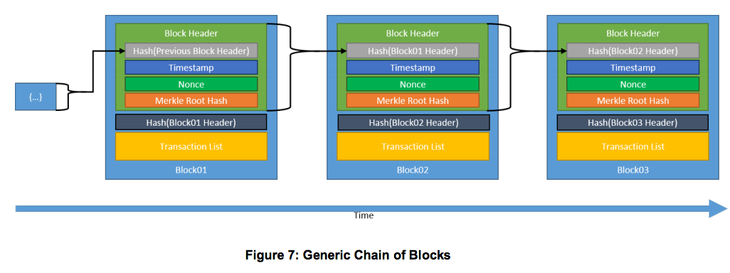
Figure 2-2 BlockChain

Transactions
The record of an event, cryptographically secured with a digital signature, that is verified, ordered, and bundled together into blocks, form the transactions in the blockchain. In the Bitcoin blockchain transactions involve the transfer of bitcoins. A smart contract within the blockchain may allow automatic execution of transactions according to predefined criteria.A transaction represent an interaction between parties. Cryptography is the study of the techniques used to allow secure communication between different parties and to ensure the authenticity and immutability of the data being communicated. For blockchain technologies. It is also used to link transactions into a block in a tamper-proof way as well as create the links between blocks to form a blockchain.

Differences between Blockchains and Databases
A blockchain is a write-only data structure where new entries get appended onto the end of the ledger. Every new block gets appended to the block chain by linking to the Hash of the previous block. There are no administrator permissions within a blockchain that allow editing or deleting of data.

In a relational database, data can be easily modified or deleted. Typically, there are database administrators who may make changes to any part of the data and/or its structure. Blockchains were designed for decentralized applications whereas relational database were originally designed for centralized applications.

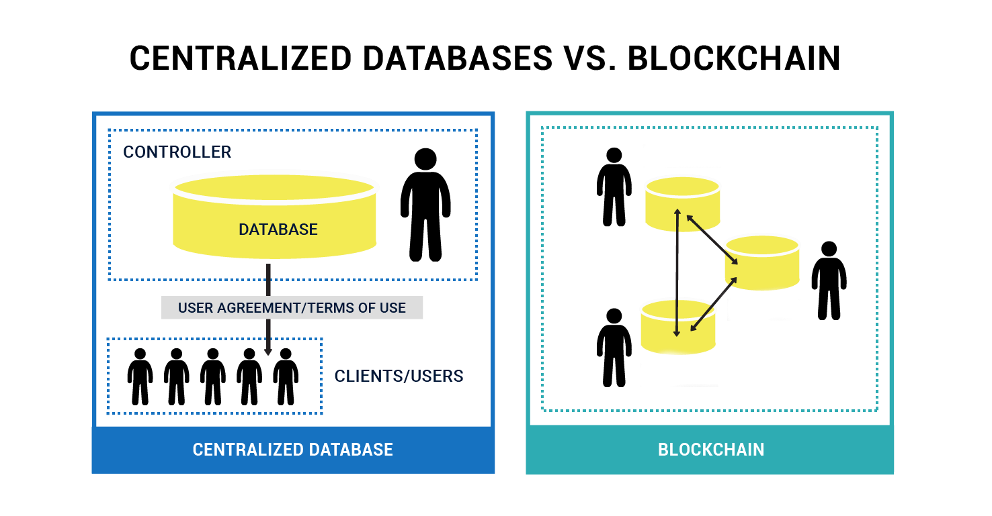
Figure 2-3 Centralized Database vs Blockchain

Immutability of Data
The immutability of the data or “unchanging over time” feature makes the blockchain useful for accounting, financial transactions, identity management, and asset ownership, management and transfer, just to name a few examples. Once a transaction is written onto the blockchain, no one can change it, or, at least, it would be extremely difficult to change it.

It is extremely hard to change the transactions in a blockchain, because each block is linked to the previous block by including the previous block's hash. This hash includes the Merkle root hash of all the transactions in the previous block. If a single transaction were to change, not only would the Merkle root hash change, but so too would the hash contained in the changed block. In addition, each subsequent block would need to be updated to reflect this change. If someone did modify a transaction in a block without going through the necessary steps to update the subsequent blocks it would be easy to recalculate the hashes used in the blocks and determine that something is missing.

In the following diagram, we see the original blocks and the transactions for Block 11. Specifically, we see that the Merkle root for the transactions in Block 11 is Hash #ABCD, which is the combined hash for the four transactions in this block. Now, let's say that someone comes in and attempts to change Transaction A to Transaction A'. This, in turn, modifies the hashes that are stored in the Merkle tree, and the Merkle root changes to Hash #A'BCD. In addition, the Previous Block hash stored in Block 12 also needs to be modified to reflect the overall change in the hash for Block 11.

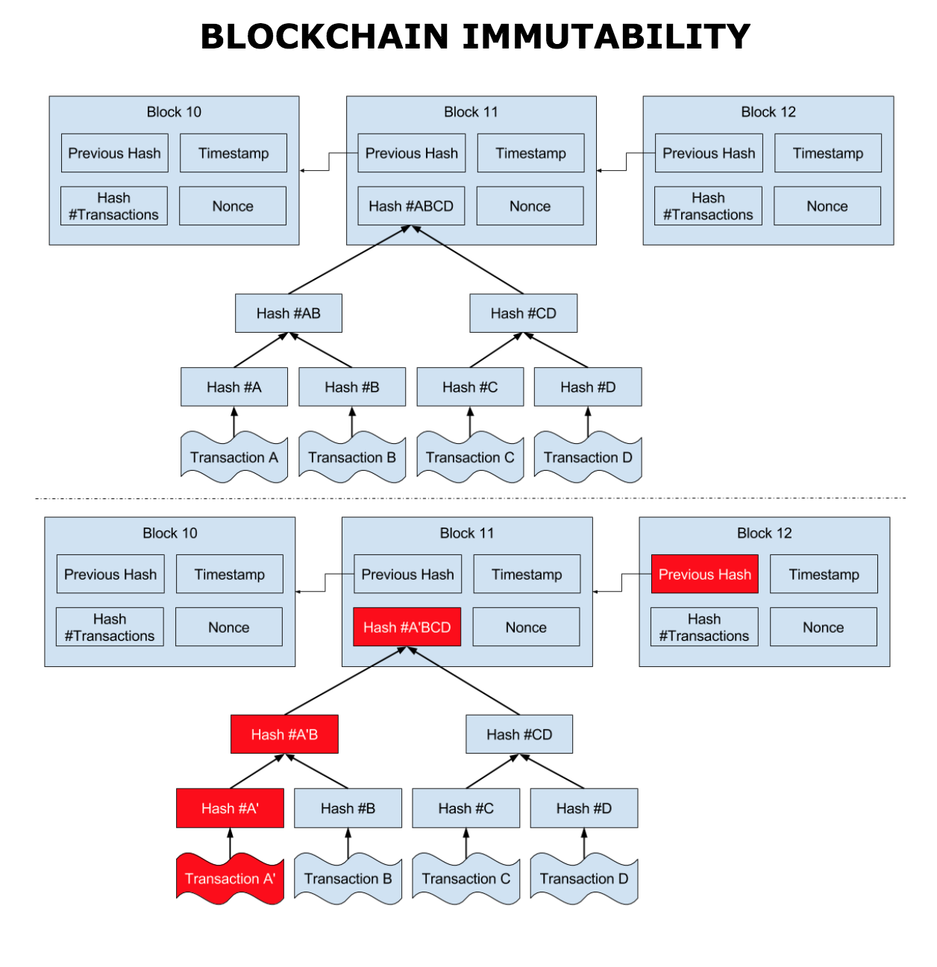
Figure 2-4 Blockchain Immutability

Hashing and Merkle Tree

Hashing
A hash is a type of function which take any variable length data as input and give random output of standard length.for example hash of ‘’alice sends bob 1 btc” is look like : “3cbcf3e1075b0b3357140de438336733bd6927cd1e78d36cc278324fcce932ad”
Cryptographic hash fumction have 3 important security properties i.e.
- They are preimage resistant i.e. they are one way.It is computationally infeasible to generate input from hash i.e. find a such that hash(a)=digest.
- They are second preimage resistant.This is it is computationally infeasible to find the 2nd input which produce the same output i.e. given a find b such that hash(a)=hash(b).
- They are collision resistant.It is computationally infeasible to find the two inputs which have same digest i.e. find a and b such that hash(a)=hash(b).
Hashes have another important property that is even a minor change in the input leads to major ouput differences.

Figure 2-5 Minor input difference leads to major output diffrences

2.4.2 Merkle Tree

Merkle tree is same as binary tree replacing regular pointers with hash pointers.Merkle trees allows computer on a network to verify individual records.It is useful for distributed network where multiple computers keep copies of the same ledger.In a Merkle tree, the leaf nodes contain the data blocks(transaction) , and the intermediate nodes contain the hash pointers. it is possible to both insert and append a node to the Merkle Tree with O(log n) operations, where n is the total number of nodes (data blocks) in the tree. Now its time to build the merkle tree.Let we take transaction T_{A}.When it is added to blockchain its become part of the block with other transaction namely as T_{B},T_{C,}T_{D}.Now we find hash of the transactions namely as H(A),H(B),H(C) and H(D).We reduce the no. Of hashes by pairing and combining the hashes i.e. H(A)+H(B)=H(AB) and H(C)+H(D)=H(CD).We can do the same thing again , H(AB)+H(CD)=H(ABCD).By doing so we at last we have only one hash that is called Merkle root.

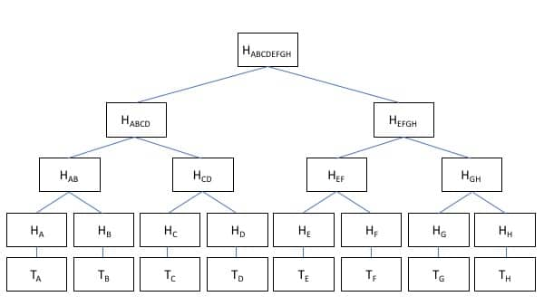

Figure 2-6 Merkle tree as a Binary tree connected by Hash pointer

Types of Blockchain
Private institutions like Banks realized that they could use the core idea of Blockchain as distributed ledger technology and create a permissioned Blockchain. Private Blockchains are valueable for solving efficiency, security and fraud problems within traditional financial institutions. Public Blockchains hold the potential to replace most functions of traditional financial institutions with software.

Centralized vs. Distributed
Distributed Ledger Technology includes blockchain technologies and smart contracts. Distributed ledgers existed prior to Bitcoin, the Bitcoin blockchain marks the convergence of a host of technologies, including timestamping of transactions, Peer-to-Peer networks, cryptography, and shared computational power, along with a new consensus algorithm.

In summary, distributed ledger technology generally consists of three basic components:
- A data model that captures the current state of the ledger
- A language of transactions that changes the ledger state
- A protocol used to build consensus among participants around which transactions will be accepted and in what order by the ledger.

Permissioned vs. Permissionless

A blockchain can be both permissionless e.g. Bitcoin,Ethereum or permissioned. A permissionless blockchain is also known as a public blockchain, because anyone can join the network. A permissioned blockchain or private blockchain requires verification of the participating parties within the network.

The choice between permissionless vs permissioned blockchains should be driven by the particular application at hand (or use case). Most enterprise use cases involve extensive vetting before parties agree to do business with each other. An example where a number of businesses exchange information is the supply chain management. The supply chain management is an ideal use case for permissioned blockchains. You would not want non-vetted companies participating in the network. Each participant that is involved in the supply chain would require permissions to execute transactions on the blockchain.When a network facilitating parties to transact without necessarily having to verify each other's identity, like the Bitcoin blockchain, a permissionless blockchain is more suitable.

Mining
Bitcoin follows a competitive mining scheme, based on a hash-puzzle. The miners have to compete with one another, using the computing resources at their disposal, to append a new block to the blockchain ledger. Bitcoin employs a smart incentive mechanism to ensure honesty of the miners. To further regulate the flow of Bitcoins, the hash-puzzle is designed in such a way that new Bitcoin blocks are created (mined) every 10 minutes,on an average. The mining competition based on the hash-puzzle is also known as a proof-of-work strategy for consensus.

Proof of Work Consensus Model
In this model user publishes block by solving computationally intensive hash-puzzle.The solution to this puzzle is proof they have performed work.The puzzle is designed in such a way that solving puzzle is difficult but checking the solution is valid is easy.This enables all other blocks to proposed any new block and any propos block that are not satisfy the puzzle criteria will be rejected.

Smart Contracts
A smart contract is a running on top of blockchain containing set of rules under which the parties interact with each other.When the predefined rules are met the aggrement is automatically enforced.It is a mechanism involving digital assets and two or more partites where some or all partities deposit assets into the smart contract and assets automatically redistributed among those partities according to formula based on certain data.

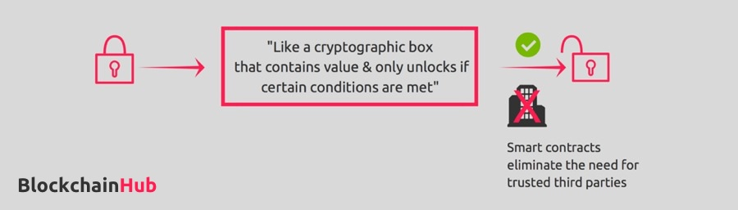

Figure 2-7 Smart Contract

Applications of Blockchain
Blockchain is a chain of blocks where each block contains data which is cryptographically secure and immutable. It will be understand that Blockchain technology is the most innovations of this century. Whenever we think of it we associate with cryptocurrencies basically Bitcoin. This article represent the applications of Blockchain technology.

Crypto Currencies
Cryptocurrency lies in its transparency and scalability which create new markets and provide more efficient resource allocation. lets an Indian with a good mastery of the English language can earn a living in customer support or as a freelancer providing translation services paid in a cryptocurrency to his private cryptocurrency wallet. Without having to go through bank. Crypto token is a coin which can be used to pay for a service or which sometimes can function as money.

Bitcoin

The Bitcoins is peer-to-peer cash system which is an example of a global decentralized payment network with a distributed and publicly-owned infrastructure, operating as a permissionless system. One can send and receive Bitcoins anywhere in the world in a completely peer to peer manner, without having to intermediate through a trusted third party (bank). Bitcoin was launched for the system was to be able to transfer value over the internet, without an intermediary. Bitcoin is programmable money. While Bitcoin is focused upon transferring monetary value between parties, it has a very limited programming language.

Ethereum
Ethereum uses a more expansive set of programming languages and tools to allow for many other types of programs and applications. The core invention of Etherium is it's EVM, or Ethereum Virtual Machine. The EVM runs on the Ethereum network, and it runs a Turing-complete software. Some of its key features include the immutability of data, that unauthorized users cannot make changes to that data, the Ethereum development platform is designed to make corruption and tamper proof applications, the secure apps are sent decentralized and secured with cryptography, and they're protected against hacking attacks and fraudulent activities and it's designed with zero downtime. That is because the applications on the network are decentralized on many machines and if some of those machines goes down the Ethereum network maintains a stable state of the Ethereum network.

Blockchain and Customer Loyalty Programs
loyyal is the universal loyalty built with Blockchain and smart contract technology. Customer loyalty and engagement can make or break companies, and as such, rewards programs represent strategic investments for all types of organizations.But as they growing rapidly they are also still weak due to inefficiencies. The reason for this is we believe the paucity of uniform management systems is a primary source of members’ lack of activity. We explore how this powerful technology can help realize the full value of customer loyalty programs. Any organization that have rewards programs can take note of the gained efficiencies, reduced costs, and enhanced brand loyalty that this powerful technology can provide. A universal loyalty platform which can be applied to existing redemption networks, and brands can also choose which other brands they want to include in their own reward app on the blockchain. Norwegian AiSpot is one company which has selected Loyyal for its travel platform. lets you build your own distributed loyalty platform, lottery games and gift card functionality.

Agriculture

The value of the blockchain here is its ability to make the supply chain entirely transparent and rich with the immutable provision of data from farm to the dining table. The blockchain will ensure that participants along the supply chain can’t temper with this information.

Blockchain has huge potential in three key areas of the agriculture industry:

- Provenance and radical transparency
Consumer demand for “clean” food, including organic but producers and manufacturers are often struggling to verify the accuracy of data from farm to table. There are no easy, accurate and efficient way for manufacturers to know about issues like slave labor and pollution or to identify the exact origin of a assets. Yet consumers, especially within appropiate markets like organic food, are increasingly willing to pay for products that provide this information. How do free-range and cage-free chickens differ, and what do the labels actually mean for animal welfare?

Startups liked Provenance and Farm share are using Blockchains to solve this problem for businesses and consumers. The value of blockchain here is its ability to tracks information about your food and participants along the supply chain cannot tamper with this information. Ultimately, this technology enables farmers, manufacturers, and retailers to justify premiums for certain products, and gives consumers confidence about where their food comes from and how it was produced.

- Mobile payments, credits, and decreased transaction fees
Blockchains also have huge potential to create and improve access to finance in the developing world. Agriculture employs over a billion people worldwide, many of whom are smallholder farmers in developing countries.

As cell phones have largely become universal, mobile banking creates new financing opportunities such as micro-financing. Yet, because of a lack of transparency and therefore high risk, the current paradigm is tons of small transactions with extremely high fees (e.g., 10%).

Blockchain can and already is solving this problem for financiers and farmers. Examples include agri-ledger out of the UK, BitPesa in East Africa, and Rebit in the Philippines.

- Real-time management of supply chain transactions and financing
Possibly the highest potential but least realized opportunity for blockchain in agriculture is in the developed world. Each year trillions of dollars flow between farmers and buyers alone. These transactions are very inefficient. Blockchain can improve the settlement process for farmers, buyers, and financiers like banks.

Right now, the exchange of the physical assets separate from the exchange of payment. In other words, farmers often deliver their harvest but then have to wait weeks or months to be paid. Farmers lack the ability to conduct due diligence on their buyer, so buyers can compete on payment terms, and therefore offer lower prices. This lessens market competition and further lowers prices as growers go to larger multinationals. And finally financing options are both costly and limited because the industry is perceived as risky and for good reason, as there are many insolvencies.

Blockchain can change all of this by enabling real-time payment on delivery. As a result, farmers get paid immediately, industry competition increases and keeps prices higher, and buyers save time and money. Also, adding transparency, trust, and efficiency to settlements can decrease risk and unlock new financing mechanisms for banks.

AgriDigital is the world's first blockchain-enabled commodity management platform. An integrated, cloud-based commodity management solution for global agricultural supply chains.

Blockchain and SDN
Securechain is the solution that introduces security gateway into SDN, whilst creating a forensically auditable and unchangeable log of events. Securechain is built on the Ethereum blockchain, the same programmable blockchain which is being considered for use by Microsoft, the R3 and Samsung/IBM.

Blockchain Platforms
Our criteria to selecting the following Blockchain platform is purely based on the subjective assessment of their ease of prototyping. We have tried all of them.

Hydrachain
Hydrachain is an open source blockchain platform developed by the joint venture of Brainbot technologies and Ethereum project. It is an extension of the Ethereum Blockchain platform which provides support to create permission Blockchain networks. Hydrachain is written in python. Smart contracts created using Hydrachain is independent of EVM and it is developed in Python programming language. EVM will execute all the untrusted codes and can provide security by restricting the accessing of each other's state. Python is an easy to use language, less time consuming and easier to debug too. So that the contract execution is fast. Hydra Chain is providing the permissioned network creation services. There will be a registered accountable validator in the network who is responsible for the validation of the blocks and transactions. In a Hydrachain network all the blocks are not allowed to enter the network without validation. That means a block will be added to the network only when the validators sign that the block is required.

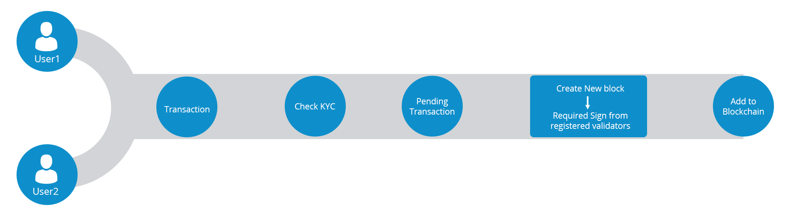
Figure 4-8 Hydrachain

Hydrachain will create a new block if and only if there is a pending transaction. Whenever the Blockchain is unable to hold a transaction then it will create new block. Validators are registered so a KYC is used for the participants, to make sure that the transaction takes place between registered participants only.

Openchain
Openchain is an open source distributed ledger technology. It is suited for organizations to issue and manage digital assets in a secure and scalable way. Openchain is a part of blockchain technology. The data in blocks get structures and they can directly order the blocks of cryptographical links and transaction done through hashing. The interlinked transaction in this technology develops the groups in blocks. These block introduce a delay into this technology. This technology is the best way to manage as well as reduce the block time to just a few seconds. There are some features of Openchain as follows :

- Instant confirmation of transaction.
- No mining fees.
- Extremely high scalability.
- Secured through digital signatures.
- The adaptability of this technology is easy and fast.
- There are no restriction to open a ledger because people can join it without any concern .

IBM Bluemix Blockchain
IBM contributed permissioned blockchain named Hyperledger Fabric. It is modular, scalable and secure. It is basically designed for industries such as agriculture, manufacturing and healthcare. It allows transaction in a secure, confidential way without a trusted authority(Bank).

Multichain
Multichain is a platform to that is used to create private blockchains. Multichain provide simple interface and command line interface.
The aim of Multichain are as following :
- Visibility of Blockchain’s activity must be kept within the authentic participants.
- Control the transaction which is permitted.
- Enable secure mining with proof of work consensus model.
- It stores the transaction related to the authentic participants.

Hyperledger
Hyperledger is a group of open source blockchain-based projects organized by The Linux Foundation. Hyperledger is really the first series of projects focused on enterprise blockchain application. It means using smart contracts to automate various business processes building a really exciting new world, secure, trustworthy information systems and automation of business processes.These benefits are valued by leaders across many industries, including technology, finance, healthcare, supply chain, and automotive, among several others.

Blockchains technologies to ensure accountability, transparency, and trust among business partners. As a result, Hyperledger makes business network and transactions more efficient. Hyperledger offers different Blockchains platforms, like: Iroha, Sawtooth, and Fabric.

Hyperledger blockchains are generally permissioned blockchains, which means that the parties that join the network are authenticated and authorized to participate on the network. Hyperledger’s main goal is to create enterprise grade, open source, distributed ledger frameworks and code bases to support business use cases.

If you look at permissionless Blockchains, like the Bitcoin or the Ethereum anyone can join the network, as well as write and read transactions. The actors in the system are not known, which means there could be some malicious actors within the network. Hyperledger reduces these security risks and ensures that only the parties that want to transact are the ones that are part of the transaction and, rather than displaying the record of the transactions to the whole network, they remain visible only to the parties involved. So, Hyperledger provides all the capabilities of the blockchain architecture data privacy, information sharing, immutability, with a full stack of security protocols all for the enterprise.

Hyperledger frameworks (Iroha, Sawtooth, Fabric, Indy, and Burrow) and modules (Cello, Explorer, and Composer).

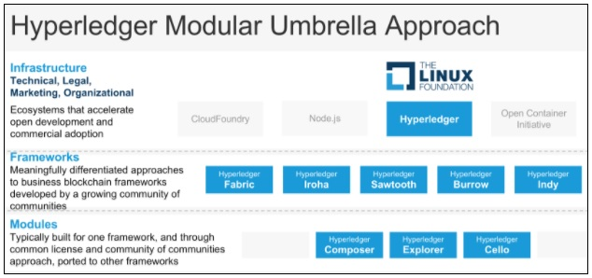
Figure 4-9 Hyperledger Modular Umbrella Approach

Components of Hyperledger Frameworks
Hyperledger business blockchain frameworks are used to build enterprise blockchains for a consortium of organizations. They are different than public ledgers like the Bitcoin blockchain and Ethereum. The Hyperledger frameworks include:

- An append-only distributed ledger
- A consensus algorithm for agreeing to changes in the ledger
- Privacy of transactions through permissioned access
- Smart contracts to process transaction requests.

Hyperledger Iroha
Hyperledger Iroha is a blockchain framework contributed by Soramitsu, Hitachi, NTT Data, and Colu. Hyperledger Iroha is designed to be simple and easy to incorporate into infrastructure projects requiring distributed ledger technology. Hyperledger Iroha emphasizes mobile application development with client libraries for Android and iOS, making it distinct from other Hyperledger frameworks. Hyperledger Iroha features a simple construction, modern, domain-driven C++ design, along with the consensus algorithm YAC.

Hyperledger Sawtooth
Hyperledger Sawtooth, contributed by Intel, is a blockchain framework that utilizes a modular platform for building, deploying, and running distributed ledgers. Distributed ledger solutions built with Hyperledger Sawtooth can utilize various consensus algorithms based on the size of the network. By default, it uses the Proof of Elapsed Time (PoET) consensus algorithm, which provides the scalability of the Bitcoin blockchain without the high energy consumption. PoET allows for a highly scalable network of validator nodes. Hyperledger Sawtooth is designed for versatility, with support for both permissioned and permissionless deployments.

Azure BaaS (Blockchain as a Service)
Azure is Microsoft’s cloud computing platform, which allows the users to manage the whole lifecycle of an application from its scratch to its termination. IT professionals can build, test and deploy the application by using the comprehensive set of services Azure offers. Microsoft Blockchain as a Service (BaaS) on Azure as an opportunity for businesses to get in touch and rapidly check the feasibility of the Blockchain technology for their purposes (proof of concept (poc)).

Blockchain on Azure provides a rapid, low-cost, low-risk platform for building and deploying blockchain applications. Azure, basically, offers Blockchain as a Service (BaaS) by providing several easy-to-deploy, enterprise-ready templates for the most popular ledgers, including Ethereum, Quorum, Hyperledger Fabric, Corda and more.

The key characteristics of building a blockchain infrastructure in Azure are:

- Establish a secure environment that exposes protected endpoints. This can be done via Azure Virtual Networks, Azure App Services VNet Integration or Network Security Groups.

- Develop smart contracts, using any of the available development tools, such as Blockstack Core, Ethereum Studio.

- Protect access to data and logic, with user-level authentication and authorization, by implementing Azure AD to secure apps and APIs.

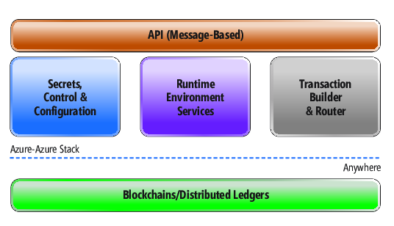
Figure 4-10 Azure Blockchain-as-a-Service Stack

Other Distributed Ledger Technologies
Chain Core, created by chain.com initially designed for financial service institutions and for things like securities, bonds, and currencies. Their company has strong ties with Visa, Citigroup, and Nasdaq.

The Corda distributed ledger platform is designed to record, manage, and automate legal agreements between businesses created by the R3 company.

Quorum is a permissioned implementation of Ethereum, which supports data privacy. Quorum achieves this data privacy through allowing data visibility on need-to-know basis by a voting-based consensus algorithm.

Implementation of a BlockChain

Java Crypto API
KeyPairGenerator class :
java provides KeyPairGenerator class.It is used to generate pairs of public and private keys.

KeyPairGenerator keyPairGen = KeyPairGenerator.getInstance("RSA");

GetIntance() :
KeyPairGenerator class provide getIntance() method which accepts a string variable representing the required key generation algorithm and returns a KeyPairGenerator objects that generate keys.

KeyPairGenerator keypairGen = KeyPairGenerator.getInstance(“DSA”);

DSA :
A digital signature algorithm (DSA) refers to a standard for digital signatures.

RSA :
RSA algorithm is asymmetric cryptography algorithm. Asymmetric actually means that it works on two different keys i.e. Public Key and Private Key. As the name describes that the Public Key is given to everyone and Private key is kept private.

KeyPairGenerator keypairGen = KeyPairGenerator.getInstance(“RSA”);
keyPairGen.initialize(2048);

Initialize() :
The KeyPairGenerator class provides a method named initialize() this method is used to initialize the key pair generator. This method accepts an integer value representing the key size.

keyPairGen.initialize(2048);

generateKeyPair() :
You can generate the KeyPair using the generateKeyPair() method of the KeyPairGenerator class.
KeyPair pair = keyPairGen.generateKeyPair();

getPrivate () :

You can get the private key from the generated KeyPair object using the getPrivate() method as shown below.

PrivateKey privKey = pair.getPrivate();
getPublic():
You can get the public key from the generated KeyPair object using the getPublic() method as shown below.
PublicKey publicKey = pair.getPublic();
Signature:
The getInstance() method of the Signature class accepts a string parameter representing required signature algorithm and returns the respective Signature object. Create an object of the Signature class using the getInstance() method.
Signature sign = Signature.getInstance("SHA256withDSA");
SHA:
Standard cryptographic library function.
InitSign():
The initSign() method of the Signature class accepts a PrivateKey object and initializes the current Signature object.Initialize the Signature object created in the previous step using the initSign() method as shown below.

sign.initSign(privKey);
Update():
The update() method of the Signature class accepts a byte array representing the data to be signed or verified and updates the current object with the data given. Update the initialized Signature object by passing the data to be signed to the update() method in the form of byte array as shown below.
byte[] bytes = "msg".getBytes();
sign.update(bytes);
Sign():
The sign() method of the Signature class returns the signature bytes of the updated data. Calculate the Signature using the sign() method as shown below.
byte[] signature = sign.sign();
MessageDigest:
A message digest is a cryptographic hash function containing a string of digits created by a one-way hashing formula. Message digests are designed to protect the integrity of a piece of data or media to detect changes and alterations to any part of a message.
MessageDigest md = MessageDigest.getInstance("SHA-256"); byte[] messageDigest = md.digest(msg.getBytes()); BigInteger no = new BigInteger(1, messageDigest);
ENCRYPT_MODE :
It is the method for encryption of any text. Following lines depicts how it’s works.
Cipher c = Cipher.getInstance("RSA");
c.init(Cipher.ENCRYPT_MODE,privateKey);
We get a RSA cipher, initialize it with the Private key this time, and encrypt the bytes.
DECRYPT_MODE :
It is the method for decryption any text. Following lines depicts how it’s works.
Cipher c = Cipher.getInstance("RSA");
c.init(Cipher.DECRYPT_MODE,publicKey);
We get a RSA cipher, initialize it with the Public key this time, and decrypt the bytes.
hashCode() : This method is used to generate the hash.
Blockchain :
Block class has three memebers such as previousHash, transactions, blockHash.
public class Block {
// Store the Hash of the previous Block
private int previousHash;
// Store the transactions of the Block
private String[] transactions;
// Store the Hash of the Block
private int blockHash;
}
Block() method is used to generate the hash of the transactions and hash of the current block hash plus previous block’s hash.
public Block(int previousHash,String[] transactions) {
// Separate current class costructor variable from class member
this.previousHash=previousHash;
this.transactions=transactions;
// Generate the Hash of the transactions
Object[] c={Arrays.hashCode(transactions),previousHash};
// Generate the Block Hash
this.blockHash=Arrays.hashCode(c);
getPreviousHash() method is used to return the hash of the previous block.
public int getPreviousHash() {
return previousHash;
}
getTransaction() method is used to return the transactions.
public String[] getTransaction() {
return transactions;
}
getBlockHash() method is used to find the current block hash.
public int getBlockHash() {
return blockHash;
}
Main class is used to store the transactions and create the blocks.
public class Main {
// Create an array to store the transactions
ArrayList<Block> blockchain=new ArrayList<>();
public static void main(String[] args) {
// Create 1st Block
String[] genesisTransactions={"A sent B 100 bitcoin","C sent D 200 btcoin"};
Block genesisBlock=new Block(0,genesisTransactions);
// Create 2nd Block
String[] block2Transactions={"E sent F 300 bitcoin","G sent H 400 bitcoin"};
Block block2=new Block(genesisBlock.getBlockHash(),block2Transactions);
}

OPENSSL to generate PRIVATE and PUBLIC KEY

PRIVATE KEY :
openssl genrsa -des3 -out private.pem 2048

To show private key file write the below command :
less private.pem

PUBLIC KEY:
openssl rsa -in private.pem -outform PEM -pubout -out public.pem

To show public key file write the below command :
less public.pem

OPENSSL to create Digital CERTIFICATE :

Write down the Common Name (CN) for your SSL Certificate. The CN is the fully qualified name for the system that uses the certificate. If you are using Dynamic DNS, your CN should have a wild-card, for example: *.api.com. Otherwise, use the hostname or IP address set in your Gateway Cluster (for example. 192.16.183.131 or dp1.acme.com).
- Run the following OpenSSL command to generate your private key and public certificate. Answer the questions and enter the Common Name when prompted.
openssl req -newkey rsa:2048 -nodes -keyout key.pem -x509 -days 365 -out certificate.pem
- Review the created certificate:
openssl x509 -text -noout -in certificate.pem
- Combine your key and certificate in a PKCS#12 (P12) bundle:
openssl pkcs12 -inkey key.pem -in certificate.pem -export -out certificate.p12
- Validate your P2 file.
openssl pkcs12 -in certificate.p12 -noout -info
6. Experimental Work
Generation of Merkle Root :
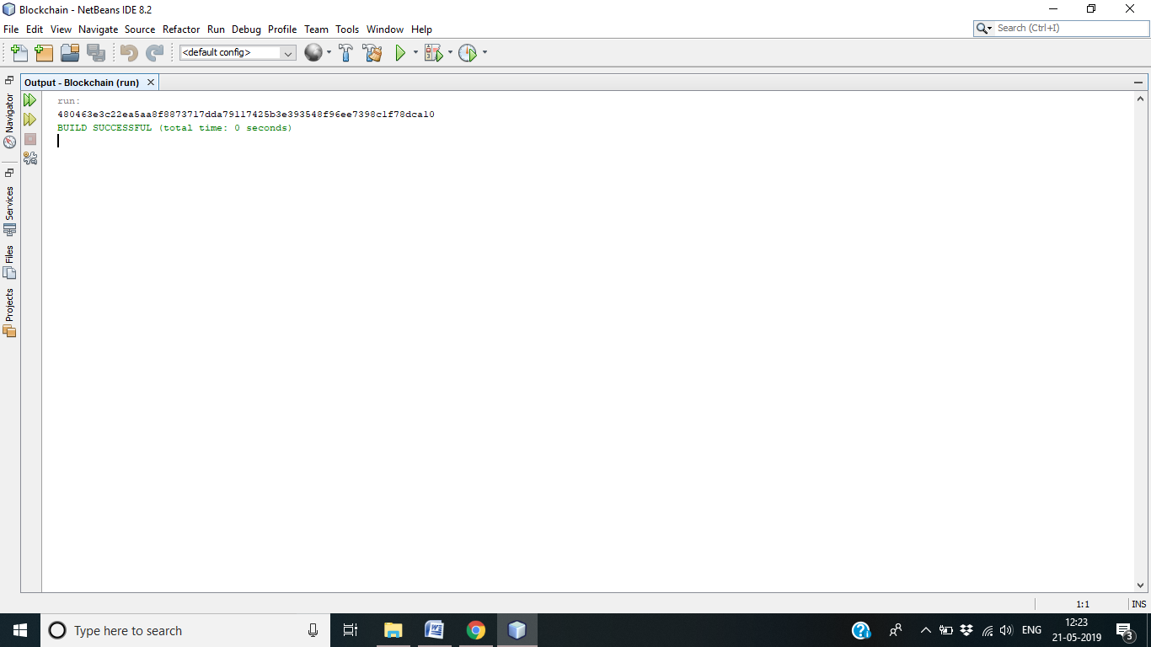

Generation of Blockchain :
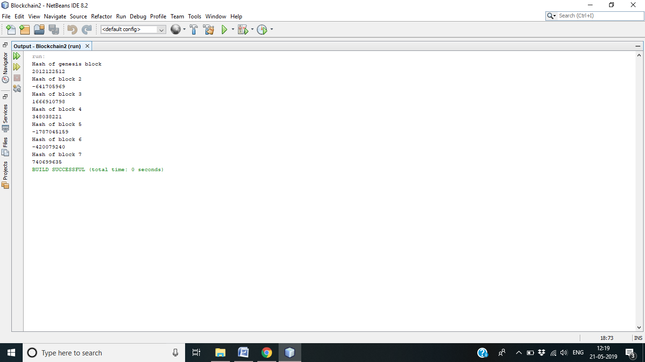

7. Future Work and Conclusion
Future Work:

Blockchain technology has a great future worldwide. An incredible scope of Blockchain technology has been observed in the financial field. The financial organizations were not able to sufficiently handle the heavy workload after demonetization and thus brought out the problems of having a centralized specialist for handling the financial transactions. The blockchain functions on a distributed database which make the operations smoothly, ensuring tight security, and made it safe from cyber-attacks. After recognizing the benefits of Blockchain technology, several financial institutions have started spending considerably in this particular field. Blockchain can also help in shortening the flow of black-money and dealing with the extensive money cleaning in the economy because each address used for transactions is stored forever on the databases, making all the transactions provable and responsible. Blockchain technology is one of the most consistent technologies when it requires to keep track of financial properties. Blockchain technology has attracted many companies who want to add the distinct features of it to their security structures.

Conclusion:

The application of Blockchain technology is not limited only to the finance industry. It has a fantastic future in different sectors such as supply chain management, digital advertising, forecasting, cyber security, Internet of things, networking, etc. With the help of Blockchain technology it is possible to transform the whole world into a much smaller place. The transactional activities can be performed much faster and efficiently using Blockchain. Blockchain technology is going to be used in many more sectors in the future such as in government systems as these systems are slow, dense, and likely to corruption. Implementing Blockchain technology in government system can make their operations much more secure and efficient.
8. Bibliography

- Blockchain Will Transform Customer Loyalty Programs, https://hbr.org/2017/03/blockchain-will-transform-customer-loyalty-programs
- Blockchain and customer loyality, https://www2.deloitte.com/us/en/pages/financial-services/articles/making-blockchain-real-customer-loyalty-rewards-programs.html
- The Internet of Loyalty, http://loyyal.com/
- Making blockchain real for customer loyalty rewards programs, https://www2.deloitte.com/us/en/pages/financial-services/articles/making-blockchain-real-customer-loyalty-rewards-programs.html
- Norwegian Travel Platform, https://medium.com/@Loyyal/aispot-selects-loyyal-to-provide-blockchain-loyalty-solution-for-norwegian-travel-platform-5c881e3d439b
- Build your distributed loyalty platform, http://blockpoint.io/
- Using Blockchain for Loyalty Rewards, http://deloitte.wsj.com/cmo/2017/03/07/using-blockchain-for-loyalty-rewards/
- Loyalty programs in a blockchain world, https://www.smartbrief.com/original/2017/05/loyalty-programs-blockchain-world
- LoyalGarden, First Ðecentralised Loyalty For Culture, https://www.loyalgarden.co/
- Blockchain: Beyond Bitcoin to Agriculture, https://gro-intelligence.com/insights/blockchain-in-agriculture
- Agriledger - Blockchain for the Greater Good, Using Distributed Cryptoledger And Mobile Apps To Create A Circle Of Trust For Small Farmer Co-Operatives., http://www.agriledger.com/
- Blockchain Will Revolutionize Agriculture and Food Supply Chain, https://www.cryptocoinsnews.com/blockchain-will-revolutionize-agriculture-and-food-supply-chain/
- From Bitcoin to Agriculture: How Can Farmers Benefit from Blockchain? https://agfundernews.com/from-bitcoin-to-agriculture-how-can-farmers-benefit-from-blockchain6380.html
- https://www.provenance.org/
- AgriDigital: Trust & Transparency for Global Agricultural Supply Chains, http://www.agridigital.io/
- EdgeVerve Blockchain Framework for improved agricultural supply chain transparency, https://www.youtube.com/watch?v=P5scszG0tsg, https://www.edgeverve.com/
- IBM partners with Nestle, Unilever and other food giants to trace food contamination with blockchain, https://www.cnbc.com/2017/08/22/ibm-nestle-unilever-walmart-blockchain-food-contamination.html
- DistBlockNet: A Distributed Blockchains-Based Secure SDN Architecture for IoT Networks, http://ieeexplore.ieee.org/document/8030491/authors
- Software Defined Networking : Secure Network Function Virtualisation Using Blockchain Technologies, https://github.com/cetic/sdn-blockchain
- Cisco says blockchain ledger technology has networking role, http://searchsdn.techtarget.com/news/450423763/Cisco-says-blockchain-ledger-technology-has-networking-role
- Block-Armour, Next Gen Cyber Security Powered by Block Chain Technolohy, http://www.blockarmour.com/ (Indian Company)
- Use of a globally distributed blockchain to secure SDN, https://www.ciosummits.com/Guardtime_KSI_Use_of_a_globally_distributed_blockchain_to_secure_SDN_whitepaper_1602.pdf
- Securechain, http://www.reply.com/en/content/securechain
- Rodrigues B., Bocek T., Stiller B. (2017) Multi-domain DDoS Mitigation Based on Blockchains. In: Tuncer D., Koch R., Badonnel R., Stiller B. (eds) Security of Networks and Services in an All-Connected World. AIMS 2017. Lecture Notes in Computer Science, vol 10356. Springer, Cham
- Hydrachain : https://www.blockchainexpert.uk/blog/hydrachain-dapp
- Openchain : https://www.blockchain-council.org/blockchain/openchain-technology-features-working/ + https://docs.openchain.org/en/latest/general/overview.html
- IBM Bluemix Blockchain : https://opensourceforu.com/2018/09/an-introduction-to-hyperledger-fabric/
- Multichain : https://dzone.com/articles/introduction-to-multichainnbspblockchains
- https://blogs.msdn.microsoft.com/uk_faculty_connection/2018/01/07/tell-me-something-i-should-know-blockchain-as-a-service-on-microsoft-azure/
- https://msdn.microsoft.com/en-us/magazine/mt847188.aspx
- Ethereum White Paper - https://github.com/ethereum/wiki/wiki/White-Paper
- https://blockchain.info/
- https://ethstats.net/
- DAPPS FOR BEGINNERS, Ethereum contract tutorials. https://dappsforbeginners.wordpress.com/tutorials/your-first-dapp/
- Blockchain as a Service, https://azure.microsoft.com/en-in/solutions/blockchain/?cdn=disable
- IBM Blockchain Platform, https://www.ibm.com/blockchain/platform/
- Rubix, http://rubixbydeloitte.com/
- Ethereum blockchain as a service (EBaaS) on Microsoft Azure.
- Hyperledger, https://www.hyperledger.org/
- What is Blockchain, https://www.youtube.com/watch?v=93E_GzvpMA0
- Building a Blockchain in Under 15 Minutes - Programmer explains, https://www.youtube.com/watch?v=baJYhYsHkLM
- DEVCON1: Ethereum for Dummies - Dr. Gavin Wood, https://www.youtube.com/watch?v=U_LK0t_qaPo
- Devcon2: Ethereum in 25 Minutes, https://www.youtube.com/watch?v=66SaEDzlmP4
- http://www.goldmansachs.com/our-thinking/pages/blockchain/
- “Blockchain Disrupts Everything...or Does It?" Blockchain panel discussion at the first IEEE Computer Society TechIgnite conference.
- BLOCKCHAIN, EXPLAINED, http://mitsloan.mit.edu/newsroom/articles/blockchain-explained/
- https://www.zarantech.com/blog/future-scope-blockchain-technology/

https://www.geeksforgeeks.org/blockchain-technology-introduction/
https://blockgeeks.com/guides/ethereum/
Wikipedia
https://coincentral.com/merkle-tree-hashing-blockchain/
https://www.blockchainexpert.uk/blog/hydrachain-dapp
https://chain.com/technology/
https://www.corda.net/

